LED Scintillation test

LED Scintillation test：

LED lights experiment is one basis of comparison experiments, experiment has been used to bring the Arduino led, this time we use other I / O port and then dip LED lights to finish the experiment, we need experimental equipment in addition to each experiment must be the Arduino controller and USB download cable.
The list of components used in the experiment is as follows:
1. Red M5 LED 1 pcs
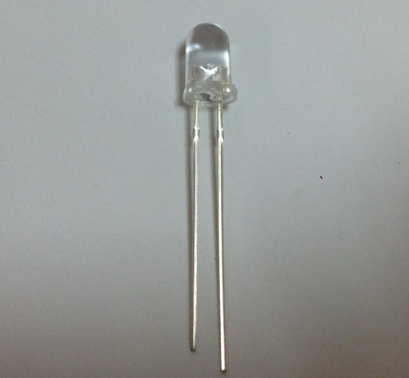
2. 220Ωline resistance*1
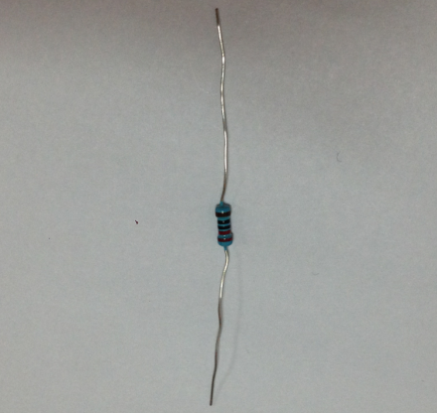
3.bread board*1
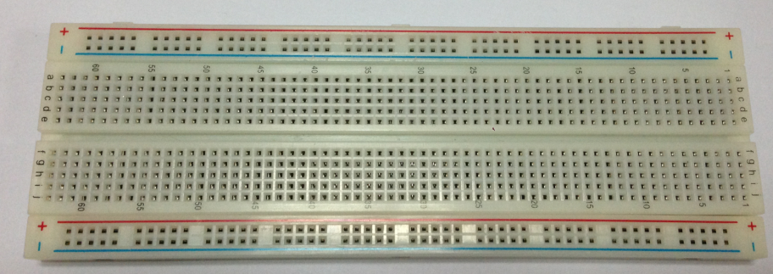
- Bread board jump line*1tie
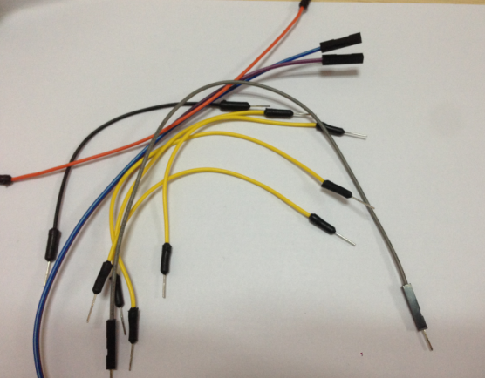

The next step we in accordance with the following lights the principle graph links physical map. Here we use the number 10 interface. Using light-emitting diode (LED), which is connected with a current limiting resistor, here is a 220 ohm resistor, or the current Congress burned light-emitting diodes.
The principle map lights:
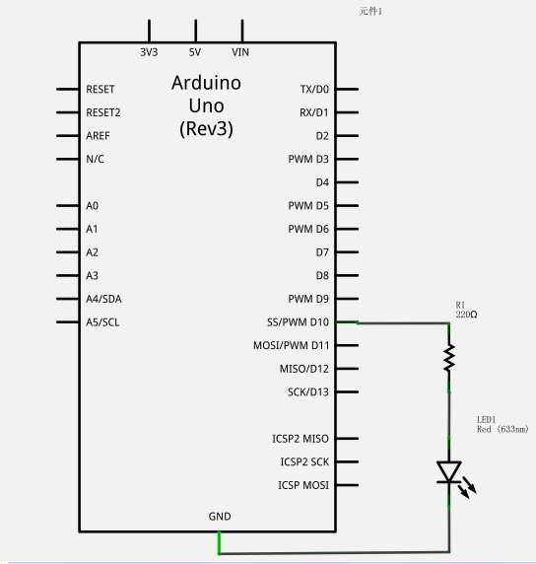
Physicaldiagramconnectiondiagram: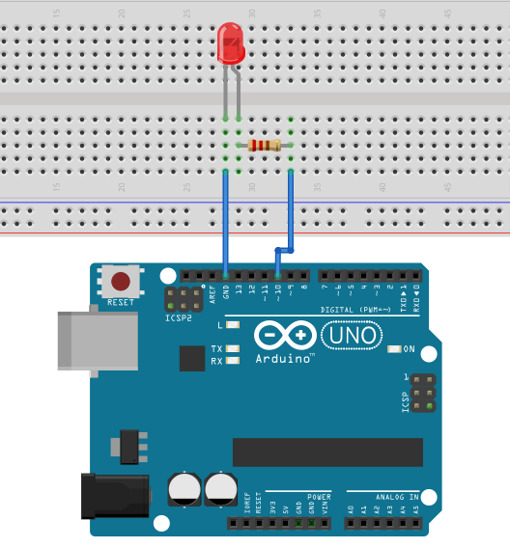

In accordance with the above link circuit, you can start writing programs, we still allow the LED lights flashing, lit 1 seconds out 1 seconds. This procedure is very simple and the Arduino comes with routine in the blink similar just 13 digital interface for 10 digital interface.。
-----------------------------------------------------------
Reference procedures are as follows：
int ledPin = 10; //Define number 10 interface
void setup()
{
pinMode(ledPin, OUTPUT);//The definition of small interface for output interface
}
void loop()
{
digitalWrite(ledPin, HIGH); //Light the lamp
delay(1000); //Delay 1 seconds
digitalWrite(ledPin, LOW); //Lights out
delay(1000); //Delay 1 seconds
}
---------------------------------------------------------
Download program you can see our 10 small lights flashing in the mouth, so that we The experimental phenomenon for the LED
flashing, the interval is about one
second.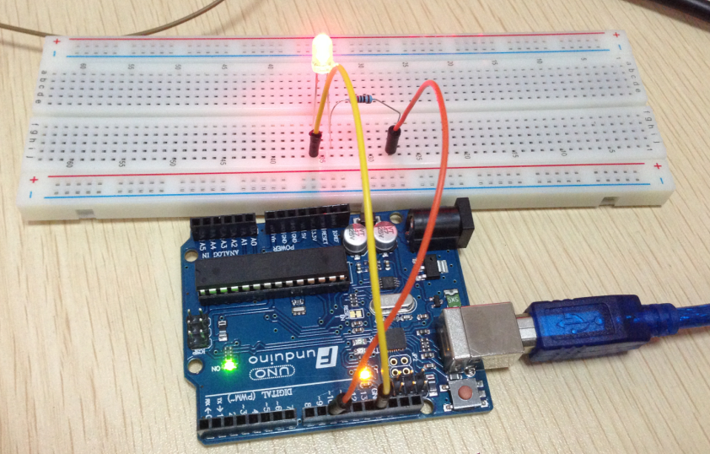
Light flicker experiment is completed.
Thank you!

